How to Submit Results with the New Multiple Results Facility.
- Log in to view the new ‘My Accounts’ page.

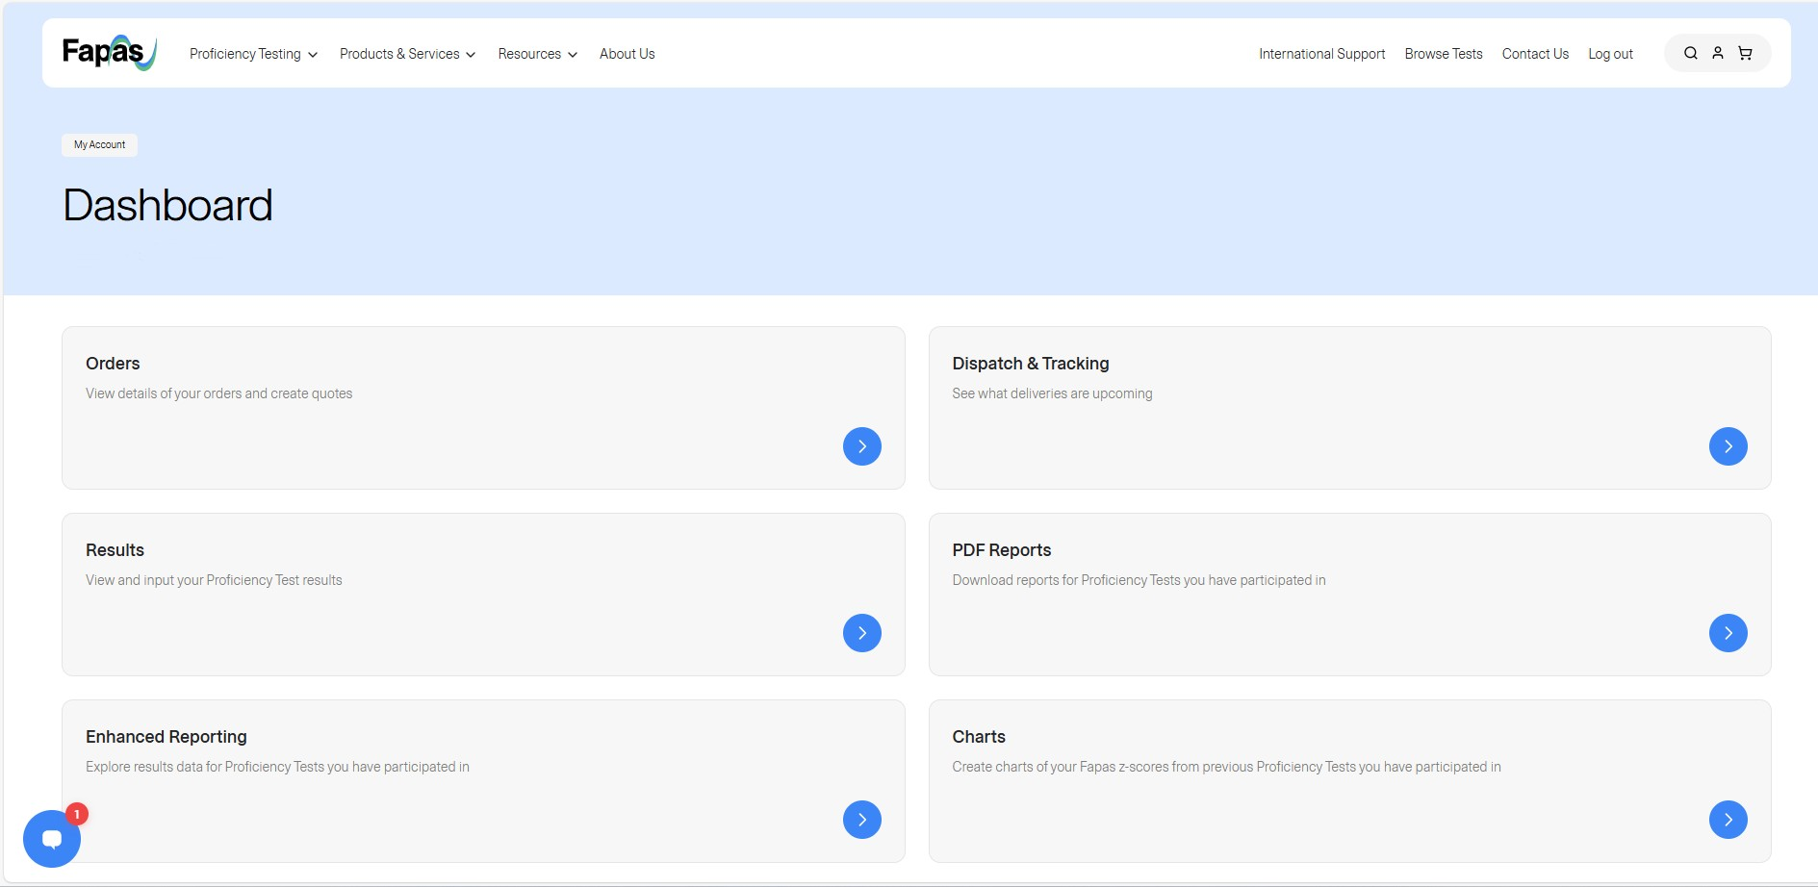

- Clicking on ‘Results’ will take you to this page. Here you can see a list of all of the proficiency tests that you are currently registered for.

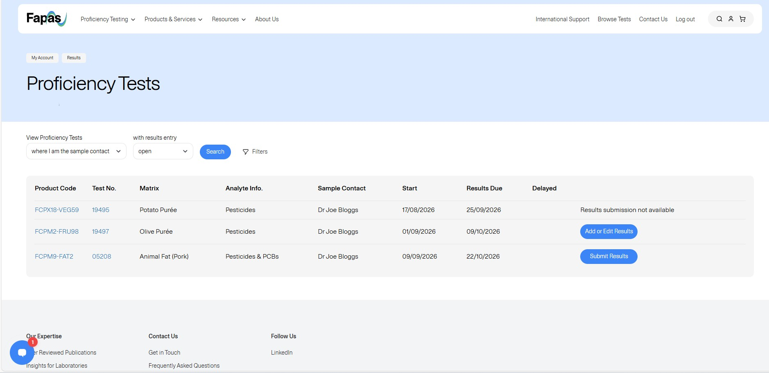

- There is an option to view either the tests for a company, tests associated to the user logged in as well as tests that are open, closed or not yet opened. A new feature on this screen is the option to filter through the proficiency tests listed on screen by test number, matrix or analyte.

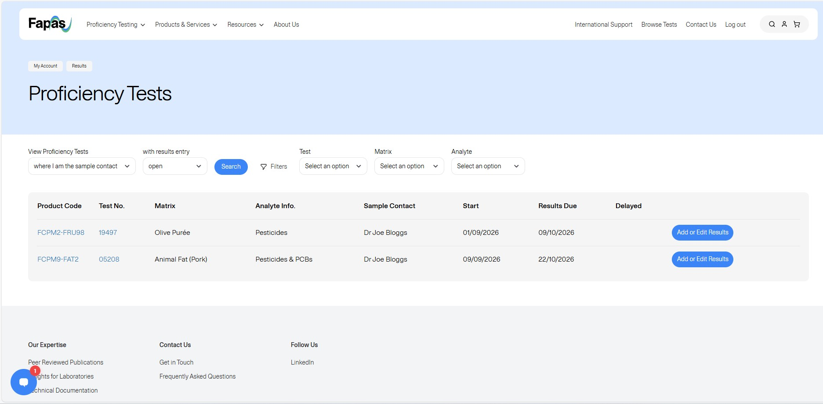

- On the right-hand side of the screen there are two options, ‘Submit Results’ and ‘Add or Edit Results’. Submit results mean that there are no results submitted by your company for this test. ‘Add or Edit Results’ mean that somebody has already entered a set of results but as testing is still open you are able to enter additional results.

- This is the intermediary screen you will reach after clicking on ‘Submit Results’ for a semi-blind test. For these tests there is now a select all option at the top of each column, so you can mark all analytes as ‘Not Detected’, ‘Not Tested’, or ‘Provide Result’ before making individual selections. After selecting which analytes you would like to provide a result for, you will move forward to the usual results entry screen.

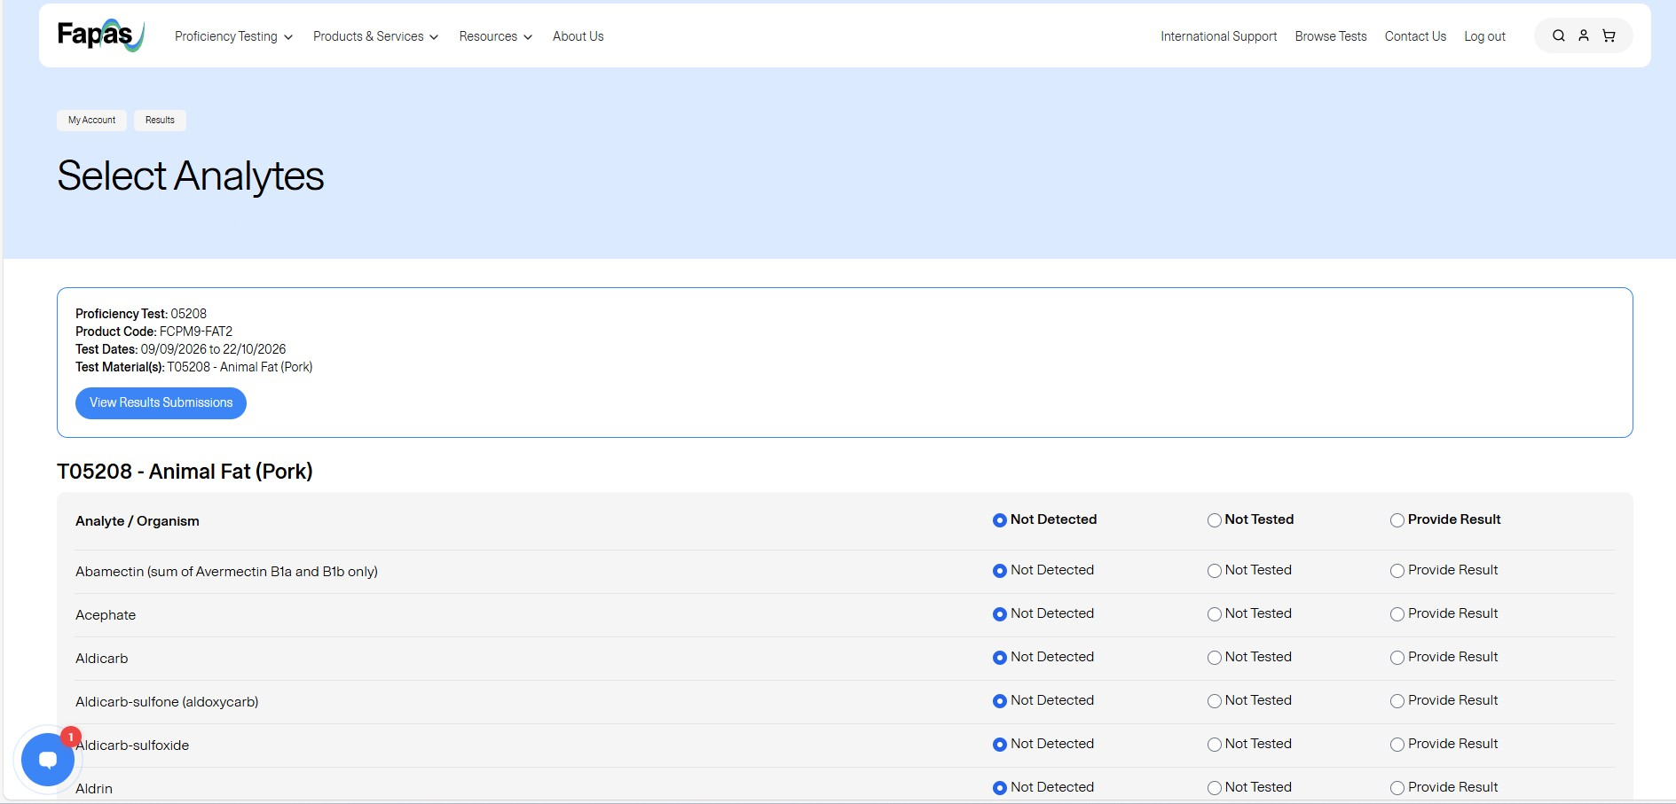

- This is the results entry screen which acts in the same way as previously.

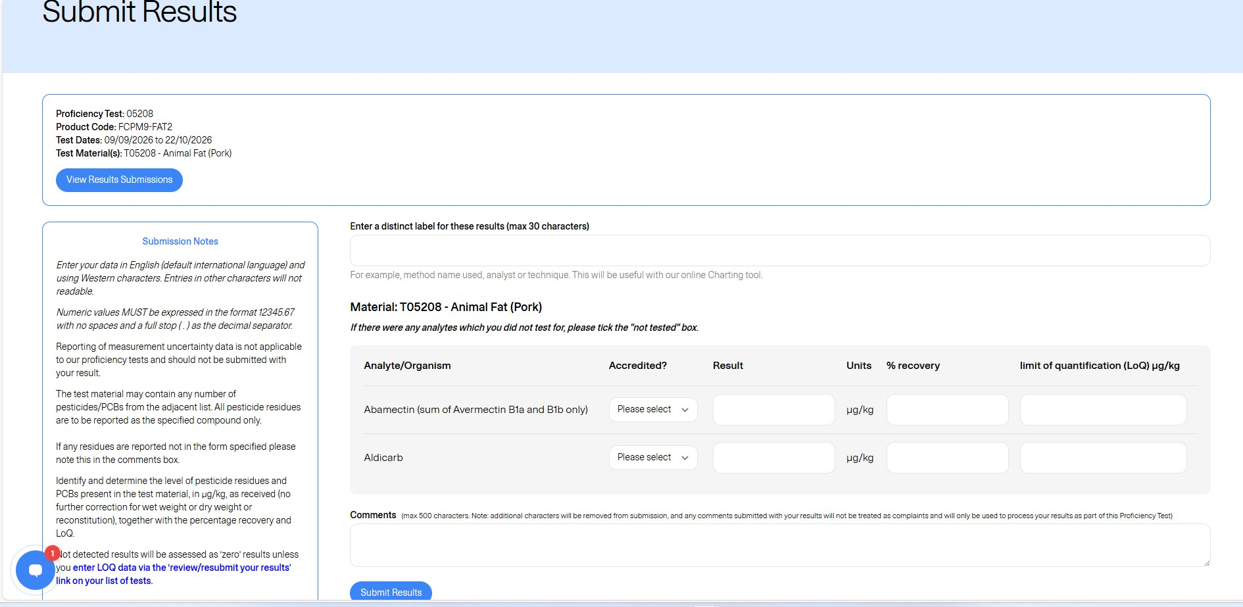

- It is mandatory to provide a reference for this result entry, this needs to be unique for each set of results entered for a proficiency test. The same reference can be used across different proficiency tests.
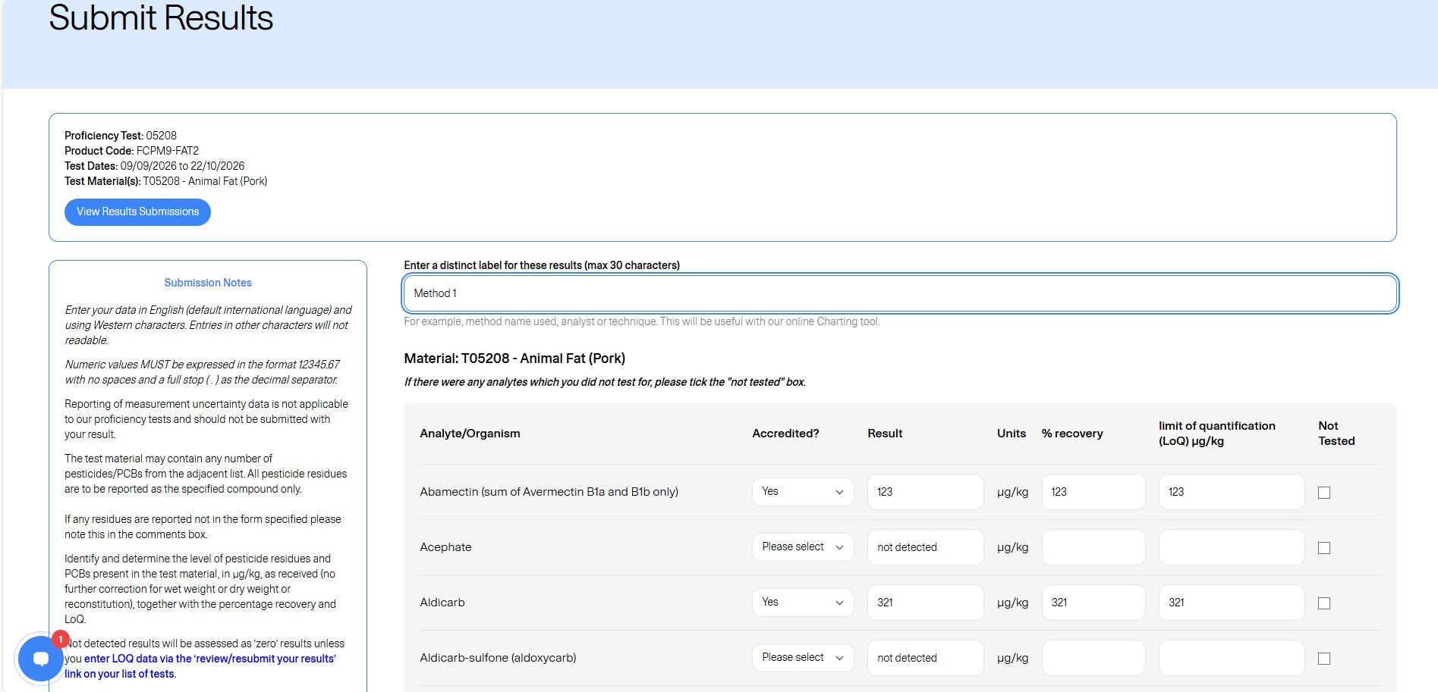

- You can now submit the results as normal for the test. Once completed please click on the ‘Submit Results’ button. From here you will be prompted to fill in the method sections.

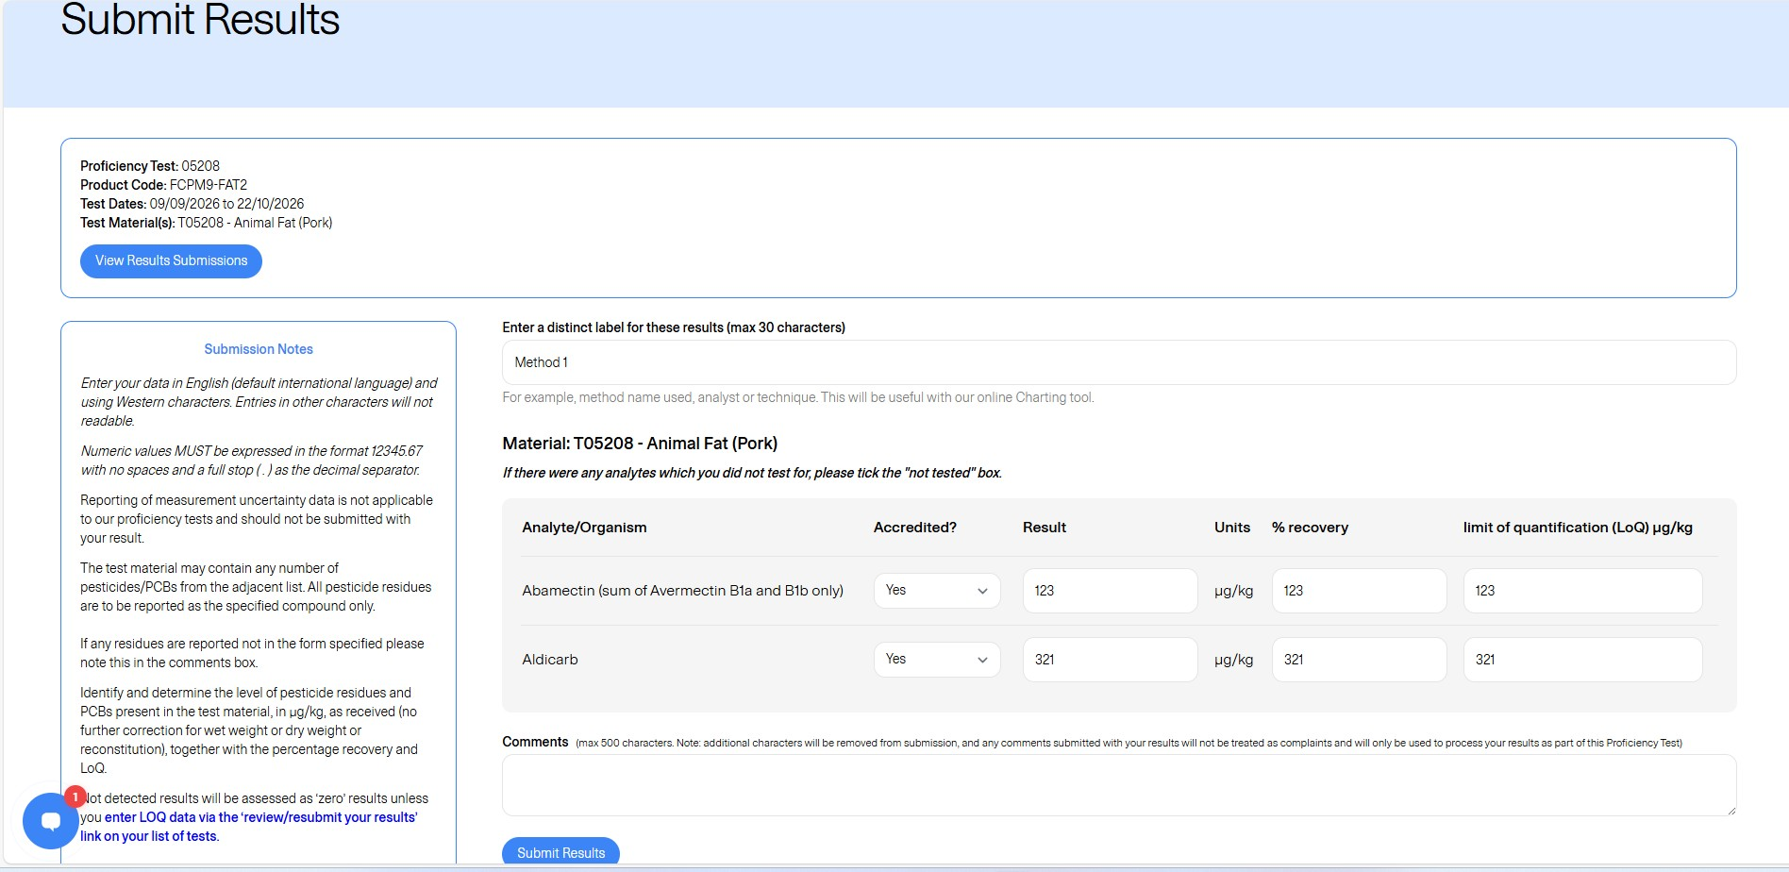

- The method sections have also been updated. After entering results, you will automatically be taken to this screen.
You will also have the option to auto-fill the method if you have answered the same method questions previously. Please note that when we update a method this option will not be available.
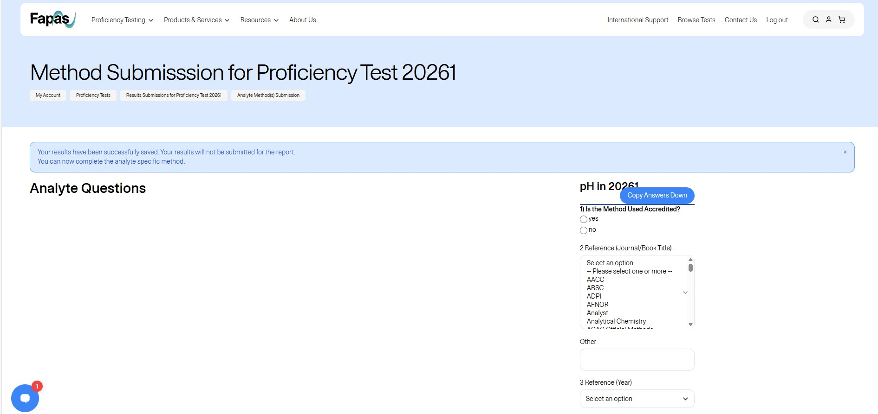

- After completing (or skipping) the methods section, you will be taken to the results submission summary page. Here you can see all of the entries, but it is only the sample contact that can see the results.
This is the screen a non-sample contact will see.

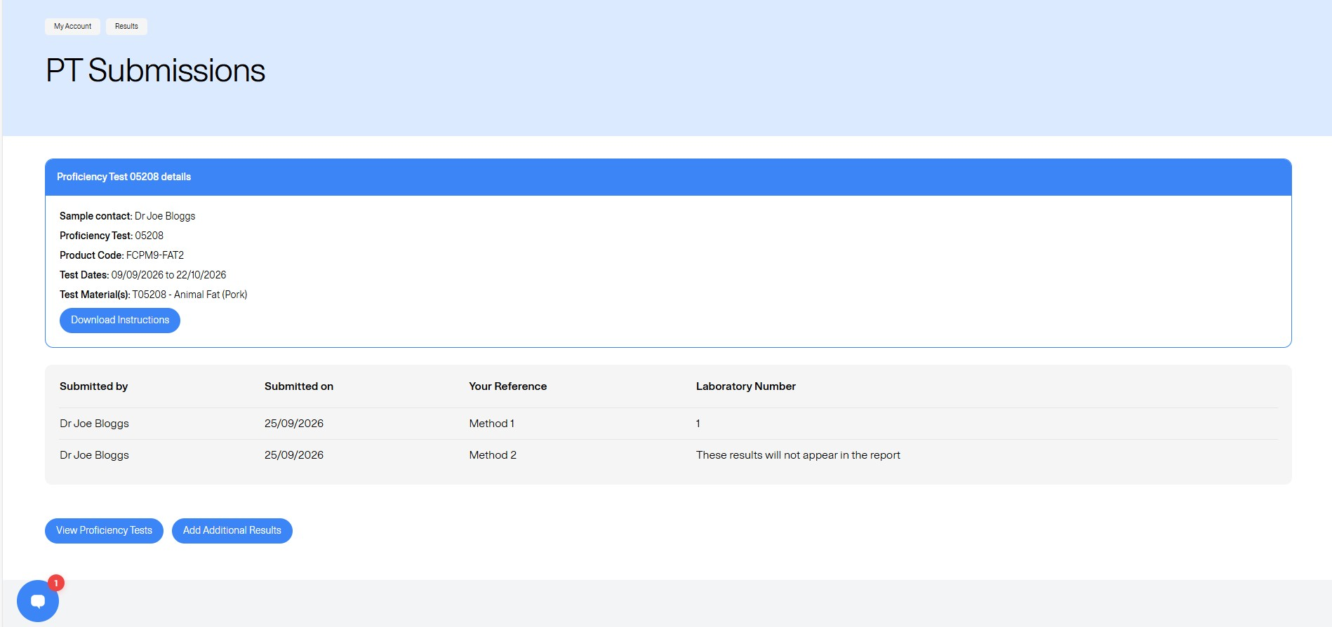

- A non-sample contact may add an additional result entry and upon doing so will note that instead of a lab number, will be assigned with ‘These results will not appear in the report’.
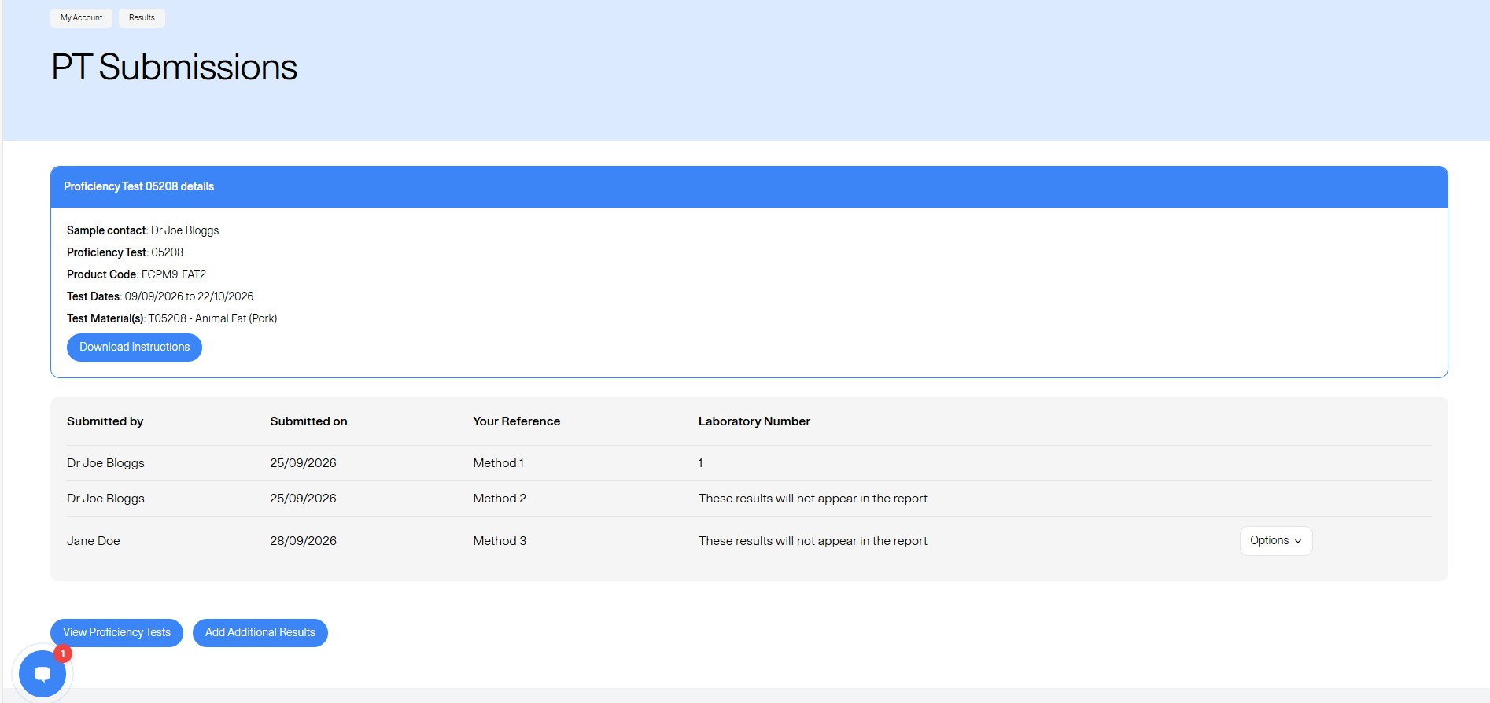

- Under ‘options’ whoever submitted the result has the option to edit or view their results, and the option to add, or view/edit their method results.

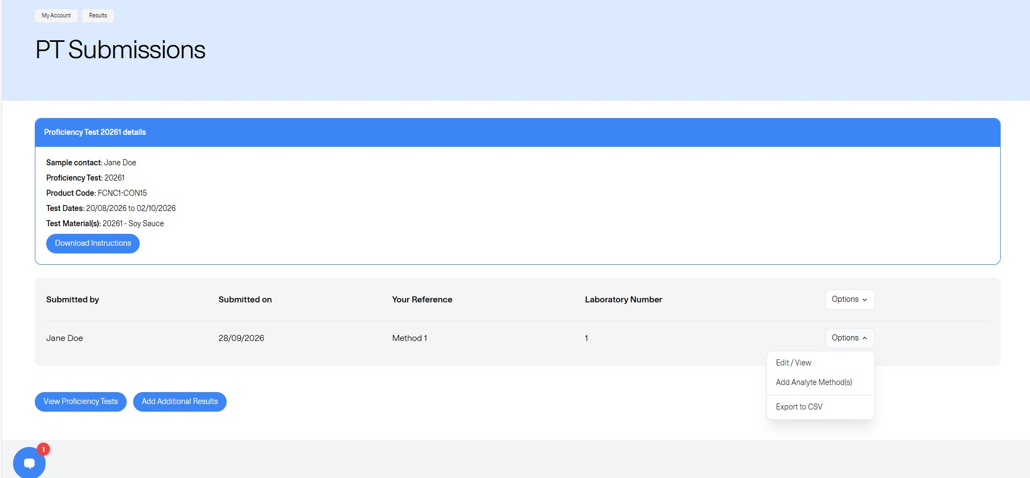

- The sample contact has a greater range of options available to them. As you can see they get the same options for all result entries, can choose which result to be set as the report results (those submitted for assessment within the report), and have the option to export all entries as a CSV file.

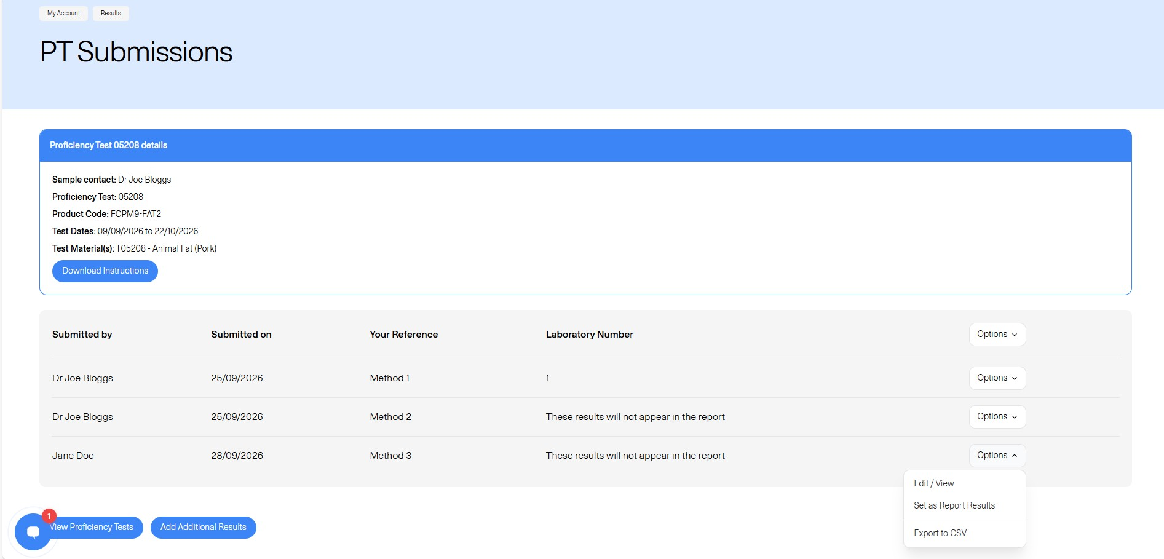

- After nominating a different results entry, we can see the first entry now says, ‘These results will not appear in the report’ and the second entry now has the associated lab number. The lab number will stay the same.

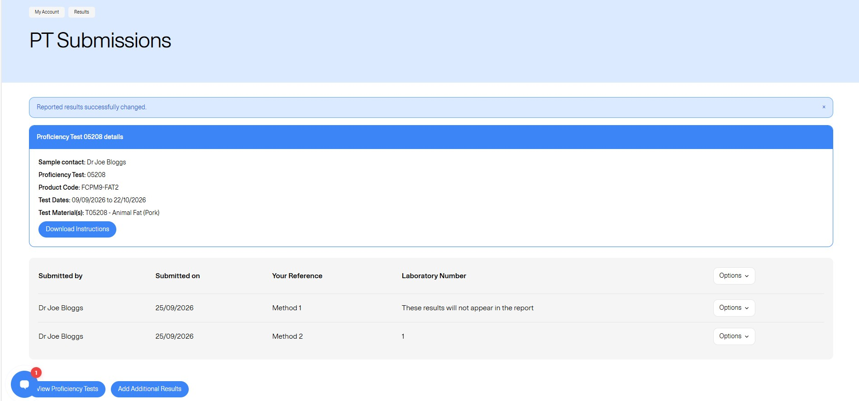

- Below is an example of the data export from this page.

